Title: | < Detailed Design Of Software >  SW Component < HWConfig >

History
Issue status  (Index) | Maturity/Date  (draft/invalid/valid)  (dd-mmm-yyyy) | Author  Department | Check/Release  Department | Description
1.0 | Draft  06-Sep-21 | Marco Granados | Marco Granados | Creation of the document

Table of Contents
1 Purpose 3
2 Definitions and abbreviations 3
3 Realization constraints and targets 3
4 SW Conceptual design 3
5 SW Component internal breakdown 4
5.1 Functional Decomposition 4
5.2 Function <Type> <function name> (type par 1, .., type par n) 5
5.3 Function <Type> <function name> (type par 1, .., type par n) 5

Purpose
This Document was created for have a detailed Component “HWConfig” that can help us to make the work most easy

Definitions and abbreviations
Definitions
Special Byte  Glitches | Special byte received to change the baud rate 55h  Usually temporary malfunction or irregularity of equipment.

Abbreviations
Only SW Component specific abbreviations.
References
N° | Document name | Reference
1 | SW Architecture description

Realization constraints and targets

An overview of which are the goals that must be achieved with these functionalities.

SW Conceptual design
In order to use a mechanism to discard glitches on the buttons
All the buttons used on the system shall use a inverted logic
This function implies to monitor periodically a signal and increment counters.

SW Component internal breakdown
For complex SW Components, the designer may define SW Subcomponents. Please consider also the work step "Deal with complexity" provided by the method for Detailed SW Design.
Note: SW Subcomponents are synonymous with the previous used term "Module"
Mapping to the file structure:
- Non complex SW Components should be represented by one object file.
- For complex SW Components each SW Subcomponent should be represented by one object file.
<Subcomponent decomposition if applicable>

Functional Decomposition
Overview of functions and their dependencies shown by a Static Function Tree
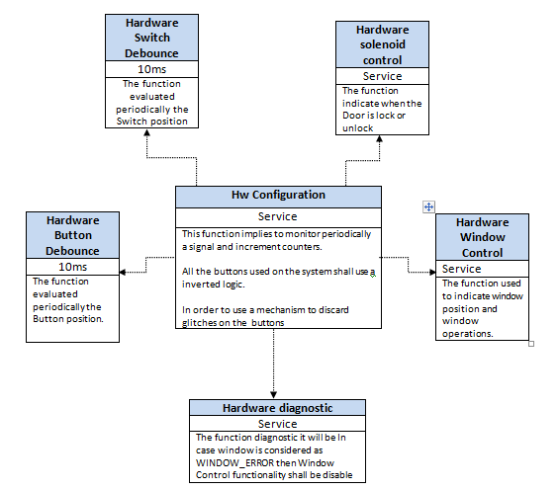
Function Description and Dynamic Behavior
Provide detailed static and dynamic description of all functions of the SW Component.
Functions which are defined in other SW Components shall only be referenced in the external interface description!
The signature description shall be done inside the function header in the source code.
For each function, the following section should be copied

Functional Hardware Button Debounce
The function evaluated periodically the Button position.

Function <Type> <function name> (type par 1, .., type par n)

Description | The function evaluated periodically the Button position.
Parameter 1  <input| output| inout> | input
Parameter 2..n | -
Return Value | none
Precondition | Button position
Post condition | Position
Error Conditions | -
Requirements | DCU_SWR_123 - 127

Functional Hardware Switch Debounce
The function evaluated periodically the Switch position.
Description | he function evaluated periodically the Switch position.
Parameter 1  <input| output| inout> | input
Parameter 2..n | -
Return Value | None
Precondition | Switch position
Post condition | Position
Error Conditions | -
Requirements | DCU_SWR_128 - 135

Functional Hardware solenoid control
The function indicate when the Door is lock or unlock.
Description | The function indicate when the Door is lock or unlock.
Parameter 1  <input| output| inout> | Out
Parameter 2..n | -
Return Value | None
Precondition | lock or unlock
Post condition | State
Error Conditions | -
Requirements | DCU_SWR_136 - 140

Functional Hardware Window Control
The function used to indicate window position and window operations.
Description | The function used to indicate window position and window operations.
Parameter 1  <input| output| inout> | Input
Parameter 2..n | -
Return Value | None
Precondition | window position
Post condition | Position
Error Conditions | -
Requirements | DCU_SWR_141 -146

Functional Hardware diagnostic
The function diagnostic it will be In case window is considered as WINDOW_ERROR then Window Control functionality shall be disable
Description | The function diagnostic it will be In case window is considered as WINDOW_ERROR then Window Control functionality shall be disable
Parameter 1  <input| output| inout> | inout
Parameter 2..n | -
Return Value | None
Precondition | function diagnostic
Post condition | Status
Error Conditions | Window_Error
Requirements | DCU_SWR_147 - 149

Dynamic Behavior
State Chart¹, Flow Chart¹
¹ Preferred
In this document, the dynamic behavior shall be designed on an abstract level showing the principle workflow of a function. Do not show the detailed implementation to ensure that the design description can be maintained with a reasonable effort. The target is not to show the complete detailed implementation 1:1.
The detailed design shall reflect in detail what a function is doing from a black box view. The internal details are useful on an abstract, but not very detailed level.
If the function is not complex a short textual description might be enough, and a graphical description is not needed.
Symbol and function names shall be self explaining.
The link to the implementation may be provided by using the same names as in the design or by a comment showing the full name followed by the declaration showing the implementation.

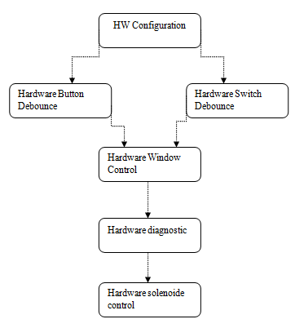

Function <Type> <function name> (type par 1, .., type par n)
Description | Brief description of the function behavior and useful remarks
Parameter 1
<input| output| inout>
Parameter 2..n
Return Value
Precondition | e.g. Function can only be called in a certain state, SW component is initialized  Relation between input parameters where applicable (Input for Module Test)
Post condition | e.g. specific State change e.g. car is locked, EEPROM Values written,  Relation between output parameters where applicable
Error Conditions
Requirements

Dynamic Behavior
State Chart¹, Flow Chart¹, Nassi Shneiderman
¹ Preferred
In this document, the dynamic behavior shall be designed on an abstract level showing the principle workflow of a function. Do not show the detailed implementation to ensure that the design description can be maintained with a reasonable effort. The target is not to show the complete detailed implementation 1:1.
The detailed design shall reflect in detail what a function is doing from a black box view. The internal details are useful on an abstract, but not on a very detailed level.
Symbol and function names shall be self explanatory.
The link to the implementation may be provided by using the same name as in the design or by a comment showing the full name followed by the declaration showing the implementation.

